1. L103000 – Triglyceride

* Data size: 52759
* Features:

|  |  |  |  |
| --- | --- | --- | --- |
| L104600 | HbA1C | FIELD_40 | physical activity (high strength) |
| FIELD_33 | Smoking | FIELD_41 | physical activity (moderate) |
| L100700 | Uric acid | FIELD_38 | Drinking 5-1 days (1 week) |
| FIELD_31 | Family history | S000502 | DBP |
| S000300 | BMI | L100800 | Fasting glucose level |
| FIELD_32 | hepatitis | L101700 | r-GTP |
| L190400 | Hemoglobin | L101300 | serum GPT |
| L103000_x | Triglyceride- last year | S000501 | SBP |

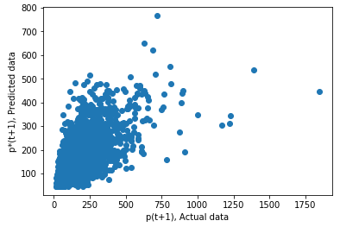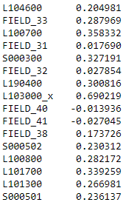

Figure 1 Correlation

* mean_squared_error 3861.384
* root mean_squared_error 62.140
* mean_absolute_error 38.42
* r2_score 0.513

1. S000300 – BMI
   1. Data size: 128085
   2. Features

|  |  |  |  |
| --- | --- | --- | --- |
| S000300 | BMI – last year | FIELD_40 | physical activity (high strength) |
| FIELD_33 | Smoking | FIELD_41 | physical activity (moderate) |
| L100700 | Uric acid | L100500 | Creatinine |
| FIELD_31 | Family history | S000502 | DBP |
| L103300 | Cardiac risk factor | L100800 | Fasting glucose level |
| L103100 | HDL-Cholesterol | L101700 | r-GTP |
| L190400 | Hemoglobin | L101300 | serum GPT |
| L103000 | Triglyceride | S000501 | SBP |

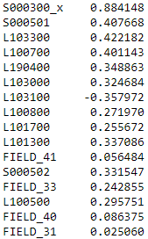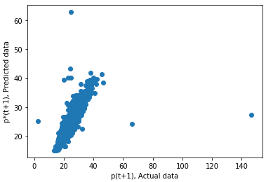

Figure 2 Correlation

* mean_squared_error 1.59
* root mean_squared_error 1.26
* mean_absolute_error 0.68
* r2_score 0.857

1. L103300 - Cardiac risk factor
   1. Data size: 44804
   2. Features

|  |  |  |  |
| --- | --- | --- | --- |
| S000300 | BMI | L102900 | total cholesterol |
| SEX | SEX | L100700 | Uric acid |
| L100700 | Uric acid | L100500 | Creatinine |
| L103200 | LDL-Cholesterol | L190500 | HCT |
| L103300 | Cardiac risk factor – last year | L100800 | Fasting glucose level |
| L103100 | HDL-Cholesterol | L104600 | HbA1C |
| L190400 | Hemoglobin | L101300 | serum GPT |
| L103000 | Triglyceride | S000501 | SBP |

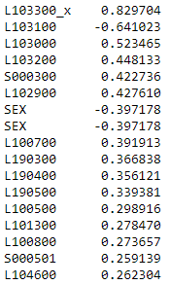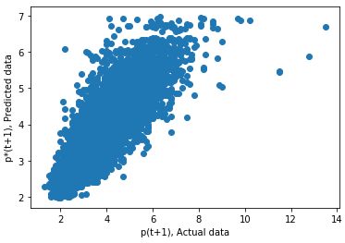

Figure 3 Correlation

* mean_squared_error 0.390
* root mean_squared_error 0.625
* mean_absolute_error 0.461
* r2_score 0.699

1. S000501 - SBP
   1. Data size: 128487
   2. Features

|  |  |  |  |
| --- | --- | --- | --- |
| S000300 | BMI | L190300 | red blood cells |
| S000502 | DBP | FIELD_42 | physical activity (walking) |
| L100700 | Uric acid | L101700 | r-GTP |
| S000100 | height | L100500 | Creatinine |
| L103300 | Cardiac risk factor | L100800 | Fasting glucose level |
| L103100 | HDL-Cholesterol | FIELD_41 | physical activity (moderate) |
| L190400 | Hemoglobin | L101300 | serum GPT |
| L103000 | Triglyceride | S000501 – last year | SBP |

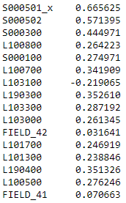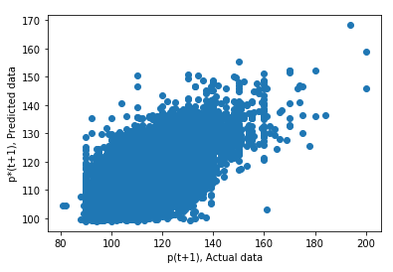

Figure 4 Correlation

* mean_squared_error 81.60
* root mean_squared_error 9.03
* mean_absolute_error 7.17
* r2_score 0.488

1. S000502 – DBP
   1. Data size: 129281
   2. Features:

|  |  |  |  |
| --- | --- | --- | --- |
| S000300 | BMI | L190300 | red blood cells |
| S000502 – last year | DBP | FIELD_42 | physical activity (walking) |
| L100700 | Uric acid | L101700 | r-GTP |
| AGE | AGE | S000100 | height |
| S010102 | Intraocular Pressure | L100800 | Fasting glucose level |
| L103100 | HDL-Cholesterol | SEX | SEX |
| L190400 | Hemoglobin | L101300 | serum GPT |
| L103000 | Triglyceride | S000501 | SBP |

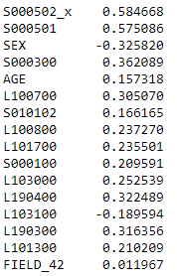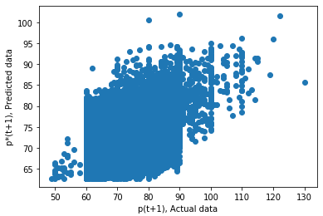

Figure 5 Correlation

* mean_squared_error 49.53
* root mean_squared_error 7.03
* mean_absolute_error 5.677
* r2_score 0.411

1. L101700 - r-GTP
   1. Data size: 128135
   2. Features

|  |  |  |  |
| --- | --- | --- | --- |
| S000300 | BMI | L190500 | HCT |
| L101600 | alkaline phosphatase | FIELD_40 | physical activity (high strength) |
| L100700 | Uric acid | L101700 | r-GTP – last year |
| FIELD_38 | Drinking 5-1 days (1 week) | L102900 | total cholesterol |
| L101200 | SGOT (AST) | L103300 | Cardiac risk factor |
| S000100 | height | SEX | SEX |
| L190400 | Hemoglobin | L101300 | serum GPT |
| L103000 | Triglyceride | S000501 | SBP |

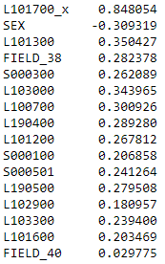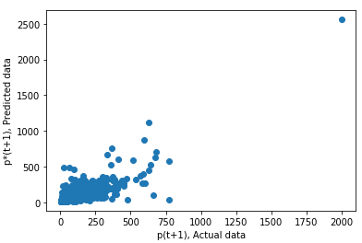

Figure 6 Correlation

* mean_squared_error 436.50
* root mean_squared_error 20.89
* mean_absolute_error 8.610
* r2_score 0.718

1. L190400 – Hemoglobin
   1. Data size: 76749
   2. Features

|  |  |  |  |
| --- | --- | --- | --- |
| S000300 | BMI | L190500 | HCT |
| L190700 | red blood cell hemoglobin | L190900 | red blood cell distribution width |
| L100700 | Uric acid | L104500 | unsaturated iron binding capacity |
| L190300 | red blood cells | L104300 | Iron (Fe) |
| L190800 | red blood cell hemoglobin concentration | L103100 | HDL-Cholesterol |
| S000100 | height | SEX | SEX |
| L190400 | Hemoglobin– last year | L101300 | serum GPT |
| L103000 | Triglyceride | S000501 | SBP |

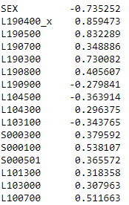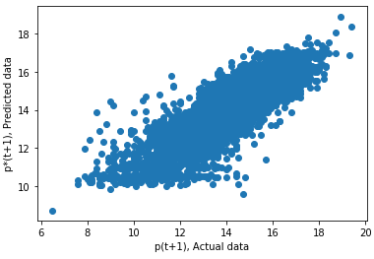

Figure 7 Correlation

* mean_squared_error 0.52
* root mean_squared_error 0.72
* mean_absolute_error 0.55
* r2_score 0.759

1. L190500 - HCT
   1. Data size: 77544
   2. Features

|  |  |  |  |
| --- | --- | --- | --- |
| S000300 | BMI | L190500 | HCT– last year |
| L190700 | red blood cell hemoglobin | L100500 | Creatinine |
| L100700 | Uric acid | L104500 | unsaturated iron binding capacity |
| L190300 | red blood cells | L104300 | Iron (Fe) |
| L190800 | red blood cell hemoglobin concentration | L103100 | HDL-Cholesterol |
| S000100 | height | SEX | SEX |
| L190400 | Hemoglobin | S000502 | DBP |
| L103000 | Triglyceride | S000501 | SBP |

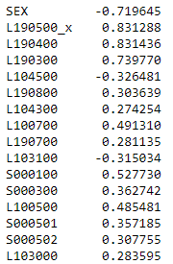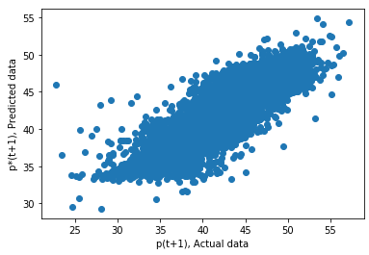

Figure 8 Correlation

* mean_squared_error 4.47
* root mean_squared_error 2.11
* mean_absolute_error 1.62
* r2_score 0.726

1. L1903 - red blood cells
   1. Data size: 138297
   2. Features

|  |  |  |  |
| --- | --- | --- | --- |
| S000300 | BMI | L190500 | HCT |
| L190600 | mean corpuscular volume | L100500 | Creatinine |
| L100700 | Uric acid | L107400 | BUN / CREA ratio |
| L190300 | red blood cells – last year | S000100 | height |
| L100200 | Thoracic and top-up (Chest Decubitus / B) | L103100 | HDL-Cholesterol |
| L101600 | alkaline phosphatase | SEX | SEX |
| L190400 | Hemoglobin | S000502 | DBP |
| L103000 | Triglyceride | S000501 | SBP |

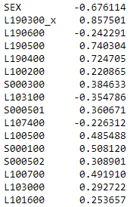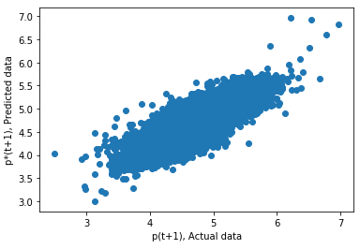

Figure 9 Correlation

* mean_squared_error 0.0481
* root mean_squared_error 0.219
* mean_absolute_error 0.171
* r2_score 0.763

1. L101300 - serum GPT
   1. Data size: 51571
   2. Features

|  |  |  |  |
| --- | --- | --- | --- |
| S000300 | BMI | L190500 | HCT |
| FIELD_32 | hepatitis | FIELD_40 | physical activity (high strength) |
| L100700 | Uric acid | FIELD_33 | 4-1 Smoking |
| FIELD_38 | Drinking 5-1 days (1 week) | L103100 | HDL-Cholesterol |
| L101200 | SGOT (AST) | L103300 | Cardiac risk factor |
| S000100 | height | L101700 | r-GTP |
| L190400 | Hemoglobin | L101300 | serum GPT– last year |
| FIELD_5 | The presence of hepatitis B | S000501 | SBP |

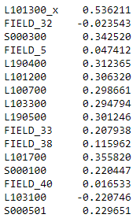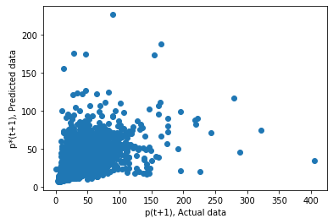

Figure 10 Correlation

* mean_squared_error 224.06
* root mean_squared_error 14.96
* mean_absolute_error 7.887
* r2_score 0.385

1. L1031 - HDL-Cholesterol
   1. Data size: 44205
   2. Features

|  |  |  |  |
| --- | --- | --- | --- |
| S000300 | BMI | L104600 | HbA1C |
| SEX | SEX | L190300 | red blood cells |
| L100700 | Uric acid | L100800 | Fasting glucose level |
| FIELD_38 | Drinking 5-1 days (1 week) | L103100 | HDL-Cholesterol– last year |
| L190000 | WBC | L103300 | Cardiac risk factor |
| S000100 | height | L190800 | red blood cell hemoglobin concentration |
| L101600 | alkaline phosphatase | L101300 | serum GPT |
| L103000 | Triglyceride | S000502 | DBP |

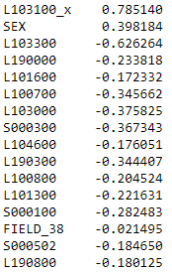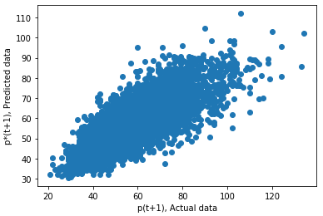

Figure 11 Correlation

* mean_squared_error 72.73
* root mean_squared_error 8.52
* mean_absolute_error 6.46
* r2_score 0.644

1. L100700 - Uric acid
   1. Data size: 58051
   2. Features

|  |  |  |  |
| --- | --- | --- | --- |
| S000300 | BMI | L100200 | Albumin |
| SEX | SEX | L101700 | r-GTP |
| L100700 | Uric acid– last year | L100500 | Creatinine |
| L107400 | BUN / CREA ratio | L103100 | HDL-Cholesterol |
| S000501 | SBP | L103300 | Cardiac risk factor |
| S000100 | height | L190800 | red blood cell hemoglobin concentration |
| L103800 | Calcium (Ca) | L101300 | serum GPT |
| L103000 | Triglyceride | S000502 | DBP |

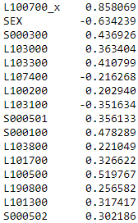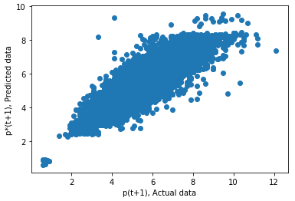

Figure 12 Correlation

* mean_squared_error 0.488
* root mean_squared_error 0.699
* mean_absolute_error 0.537
* r2_score 0.751

1. L103000 - Triglyceride - with Drugs=1
   1. Data size: 190
   2. Features

|  |  |  |  |
| --- | --- | --- | --- |
| L104400 | TIBC | L191100 | platelet concrete |
| L104300 | Iron (Fe) | L103300 | Cardiac risk factor |
| L100700 | Uric acid | FIELD_38 | Drinking 5-1 days (1 week) |
| FIELD_35 | smoking before smoking an average day | S000502 | DBP |
| S000300 | BMI | L100800 | Fasting glucose level |
| FIELD_32 | hepatitis | L101700 | r-GTP |
| S001200 | the waist (Waist line) | S000200 | weight (Weight) |
| L103000_x | Triglyceride- last year | L190000 | WBC |

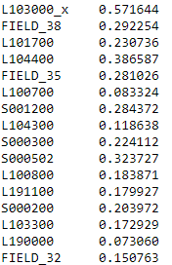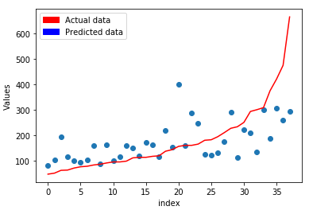

Figure 13 Correlation

* mean_squared_error 11455.60
* root mean_squared_error 107.03
* mean_absolute_error 74.86
* r2_score 0.318

1. S000501 – SBP – with drugs
   1. Data size: 8011
   2. Features

|  |  |  |  |
| --- | --- | --- | --- |
| S000300 | BMI | L101200 | serum GOT |
| S000502 | DBP | L100800 | Fasting glucose |
| S000501 – last year | SBP | S010101 | Intraocular Pressure |
| AGE | AGE | S001200 | waistline |
| L101600 | alkaline phosphatase | S010102 | Intraocular Pressure |
| L101400 | LDH | S000200 | weight (Weight) |
| L100100 | Total-Protein | L100300 | Globulin |
| L102900 | total cholesterol | L190300 | red blood cells |

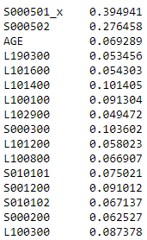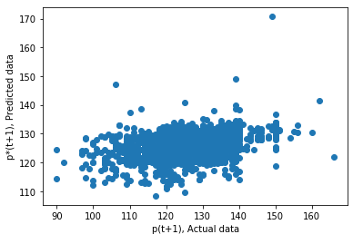

Figure 14 Correlation